COMPLETE TECHNICAL SPECIFICATION
Moneybags Banking System
Data schema, permission model, microservices architecture, end-to-end processing and implementation blueprint
Technology baseline: Oracle Database, Spring Boot microservices, Spring Cloud Gateway, Oracle JavaScript Extension Toolkit, and Kafka or RabbitMQ for asynchronous events.

Revised edition | 5 August 2026
Includes rendered system diagrams and the approved six-product seed catalogue.

Document purpose and scope
This document consolidates the supplied Moneybags Banking System specification and architecture notes into an implementation-ready reference. Mermaid and text-based schema blocks have been replaced with rendered diagrams. The end-to-end flows have been expanded to identify the responsible service, synchronous calls, events, database effects, permissions and failure handling.

Contents
- 1. Relational database schemas and sample data
- 2. Architecture and microservices grouping
- 3. Detailed service responsibilities and communication
- 4. Expanded end-to-end flows
- 5. Privacy, accounting and operational safeguards
- 6. Implementation checklist by microservice
- 7. Rendered system diagram suite
Sample-data convention: All personal details are fictional. Email addresses use example.test, passwords are represented only by BCrypt placeholders, Aadhaar is masked/tokenised, and monetary values are expressed in Indian rupees.

1. Relational Database Schemas and Sample Data
The logical model uses Oracle-compatible data types and constraints. Each microservice owns its schema; cross-service identifiers are stored as logical references and validated through service contracts rather than cross-schema joins.

1.1 Roles Table (ROLES)
id (PK) | name (UK) | description
1 | ADMIN | System administrator with full platform access
2 | TELLER | Branch teller for cash and counter operations
3 | BRANCH_MANAGER | Branch supervisor for approvals and overrides
4 | LOAN_OFFICER | Officer responsible for loan evaluation
5 | AUDITOR | Read-only compliance and audit access
6 | CUSTOMER | End user limited to owned banking resources

1.2 Permissions Table (PERMISSIONS)
id | permission_code (UK) | name / purpose | service_name | action
1 | USER_MANAGE | Manage users, status and role assignment | auth-service | MANAGE
2 | ROLE_PERMISSION_MANAGE | Manage roles and permission mappings | auth-service | MANAGE
3 | CUSTOMER_READ | Read customer and KYC summary | customer-service | READ
4 | CUSTOMER_UPDATE | Update customer profile | customer-service | UPDATE
5 | KYC_VERIFY | Verify or reject KYC documents | customer-service | APPROVE
6 | PRODUCT_READ | View product catalogue and rules | product-service | READ
7 | PRODUCT_MANAGE | Create and change products and rates | product-service | MANAGE
8 | ACCOUNT_OPEN | Create an account application | account-service | CREATE
9 | ACCOUNT_APPROVE | Approve or reject account opening | account-service | APPROVE
10 | ACCOUNT_VIEW | View permitted account details and balances | account-service | READ
11 | ACCOUNT_STATUS_MANAGE | Freeze, unfreeze, block or close account | account-service | MANAGE
12 | TRANSACTION_CREATE | Initiate an allowed financial transaction | transaction-service | CREATE
13 | TRANSACTION_APPROVE | Approve maker-checker transactions | transaction-service | APPROVE
14 | TRANSACTION_REVERSE | Create compensating reversal | transaction-service | REVERSE
15 | STATEMENT_VIEW | Generate permitted statements | reporting-service | READ
16 | AUDIT_READ | Search and export audit records | audit-service | READ
17 | CONFIG_MANAGE | Change limits, policies and feature flags | config-service | MANAGE

1.3 Role-Permission Mapping (ROLE_PERMISSIONS)
role | permissions | scope rule
ADMIN | All permissions | Unrestricted administrative access; still audited
TELLER | CUSTOMER_READ, ACCOUNT_OPEN, ACCOUNT_VIEW, TRANSACTION_CREATE | Branch-scoped counter operations
BRANCH_MANAGER | Teller permissions plus KYC_VERIFY, ACCOUNT_APPROVE, ACCOUNT_STATUS_MANAGE, TRANSACTION_APPROVE, TRANSACTION_REVERSE | Branch-scoped maker-checker authority
LOAN_OFFICER | CUSTOMER_READ, KYC_VERIFY, PRODUCT_READ, ACCOUNT_VIEW | Loan-domain permissions can be added later
AUDITOR | AUDIT_READ, CUSTOMER_READ, ACCOUNT_VIEW, STATEMENT_VIEW | Read-only compliance access
CUSTOMER | PRODUCT_READ, ACCOUNT_OPEN, ACCOUNT_VIEW, TRANSACTION_CREATE, STATEMENT_VIEW | Object ownership must match authenticated CIF

Permission enforcement: The Gateway performs coarse route checks. The target service performs the final permission, branch scope, account ownership and maker-checker validation. The initiating user cannot approve the same operation.

1.4 Users Table (USERS)
id | first_name | last_name | email (UK) | password_hash | role_id | status | created_at | last_login_at
101 | Rajesh | Sharma | rajesh.sharma@example.test | $2a$12$DEMO...9a2 | 1 | ACTIVE | 2026-01-10 | 2026-08-04 14:22
102 | Priya | Nair | priya.nair@example.test | $2a$12$DEMO...1b8 | 3 | ACTIVE | 2026-01-12 | 2026-08-05 08:11
103 | Amit | Patel | amit.patel@example.test | $2a$12$DEMO...4c3 | 2 | ACTIVE | 2026-01-15 | 2026-08-05 09:00
104 | Vikram | Rao | vikram.rao@example.test | $2a$12$DEMO...8x1 | 6 | ACTIVE | 2026-02-01 | 2026-08-04 18:45
105 | Ananya | Deshmukh | ananya.d@example.test | $2a$12$DEMO...2y9 | 6 | ACTIVE | 2026-02-10 | 2026-08-03 11:12

1.5 Branches and Employees
id | branch_code | name | address | city | state | pincode | ifsc_code
501 | MB001 | Mumbai Fort Main | 14 Nariman Point, MG Road | Mumbai | Maharashtra | 400021 | MBAG0000001
502 | MB002 | Bangalore MG Road | 88 Trinity Circle, MG Road | Bengaluru | Karnataka | 560001 | MBAG0000002

id | user_id | employee_code | dob | branch_id | designation | manager_id | joining_date | status
1001 | 101 | EMP-001 | 1985-05-14 | 501 | System Administrator | NULL | 2020-01-15 | ACTIVE
1002 | 102 | EMP-002 | 1988-11-22 | 501 | Branch Manager | 1001 | 2021-03-01 | ACTIVE
1003 | 103 | EMP-003 | 1994-08-09 | 501 | Senior Teller | 1002 | 2022-06-15 | ACTIVE

1.6 Customers, Addresses and KYC Documentation
cif | user_id | customer_type | dob | gender | mobile | PAN | Aadhaar display | KYC status
CIF900101 | 104 | INDIVIDUAL | 1992-03-18 | MALE | +91 98200 12345 | ABCDE1234F | XXXX-XXXX-4321 | VERIFIED
CIF900102 | 105 | INDIVIDUAL | 1995-07-25 | FEMALE | +91 98765 43210 | XYZPS5678G | XXXX-XXXX-8765 | VERIFIED

id | cif | address_type | line1 | line2 | city | state | pincode
2001 | CIF900101 | PERMANENT | A-401, Sun City | Heights | Mumbai | Maharashtra | 400076
2002 | CIF900101 | CURRENT | Flat 202, Green Acres | Indiranagar | Bengaluru | Karnataka | 560038
2003 | CIF900102 | PERMANENT | 77 Blue Ridge Society | Hinjewadi | Pune | Maharashtra | 411057

id | cif | document_type | document_number_hash | storage_path | verification_status | uploaded_at
3001 | CIF900101 | PAN_CARD | SHA-256: e3b0...b855 | /docs/kyc/cif900101_pan.pdf | VERIFIED | 2026-02-01 14:25
3002 | CIF900101 | AADHAAR_CARD | SHA-256: 8f43...27aa4 | /docs/kyc/cif900101_aadhaar.pdf | VERIFIED | 2026-02-01 14:26

1.7 Approved Product Seed Catalogue (PRODUCTS)
id | product_code | name | product_type | interest_rate | min_balance | tenure_months
1 | SAV-REG | Regular Savings Account | DEPOSIT | 3.00% | ₹1,000 | NULL
2 | SAV-SENIOR | Senior Citizen Savings | DEPOSIT | 3.50% | ₹1,000 | NULL
3 | CUR-BASIC | Basic Current Account | DEPOSIT | 0.00% | ₹10,000 | NULL
4 | FD-12M | 12-Month Fixed Deposit | DEPOSIT | 6.80% | ₹5,000 | 12
5 | FD-24M | 24-Month Fixed Deposit | DEPOSIT | 7.10% | ₹5,000 | 24
6 | RD-12M | 12-Month Recurring Deposit | DEPOSIT | 6.50% | ₹500 | 12

Product-model update: Demand-deposit products use NULL tenure. FD and RD products require the configured tenure. Production lifecycle columns such as status, effective_from, effective_to, created_at and updated_at remain recommended even though the approved seed dataset above contains the seven business columns requested.

1.8 Accounts, Transactions and Ledger Entries
id | account_number | cif | product_id | branch_id | account_type | status | available_balance | opened_at
8001 | 100011000101 | CIF900101 | 1 | 501 | SAVINGS | OPEN | ₹45,250 | 2026-02-02
8002 | 100011000102 | CIF900102 | 1 | 502 | SAVINGS | OPEN | ₹12,800 | 2026-02-11

id | txn_ref | account_id | counter_id | txn_type | amount | mode | description | status | created_at | created_by
90001 | TXN20260801001 | 8001 | NULL | CREDIT | ₹50,000 | CASH | Initial deposit | SUCCESS | 2026-02-02 11:15 | 103
90002 | TXN20260802045 | 8001 | 8002 | DEBIT | ₹4,750 | UPI | Transfer to Ananya | SUCCESS | 2026-08-04 15:30 | 104

id | txn_id | account_id | entry_type | amount | posting_date | narration
70001 | 90001 | 8001 | CREDIT | ₹50,000 | 2026-02-02 11:15 | Cash deposit - Branch 501
70002 | 90002 | 8001 | DEBIT | ₹4,750 | 2026-08-04 15:30 | UPI outward to 100011000102
70003 | 90002 | 8002 | CREDIT | ₹4,750 | 2026-08-04 15:30 | UPI inward from 100011000101

2. Architecture and Microservices Grouping
The ecosystem follows domain-driven boundaries and the core pipeline Customer -> Product -> Account -> Transaction -> Ledger. Immediate validations use synchronous REST or gRPC. Notifications, audit trails and reporting projections are delivered asynchronously through an event bus.
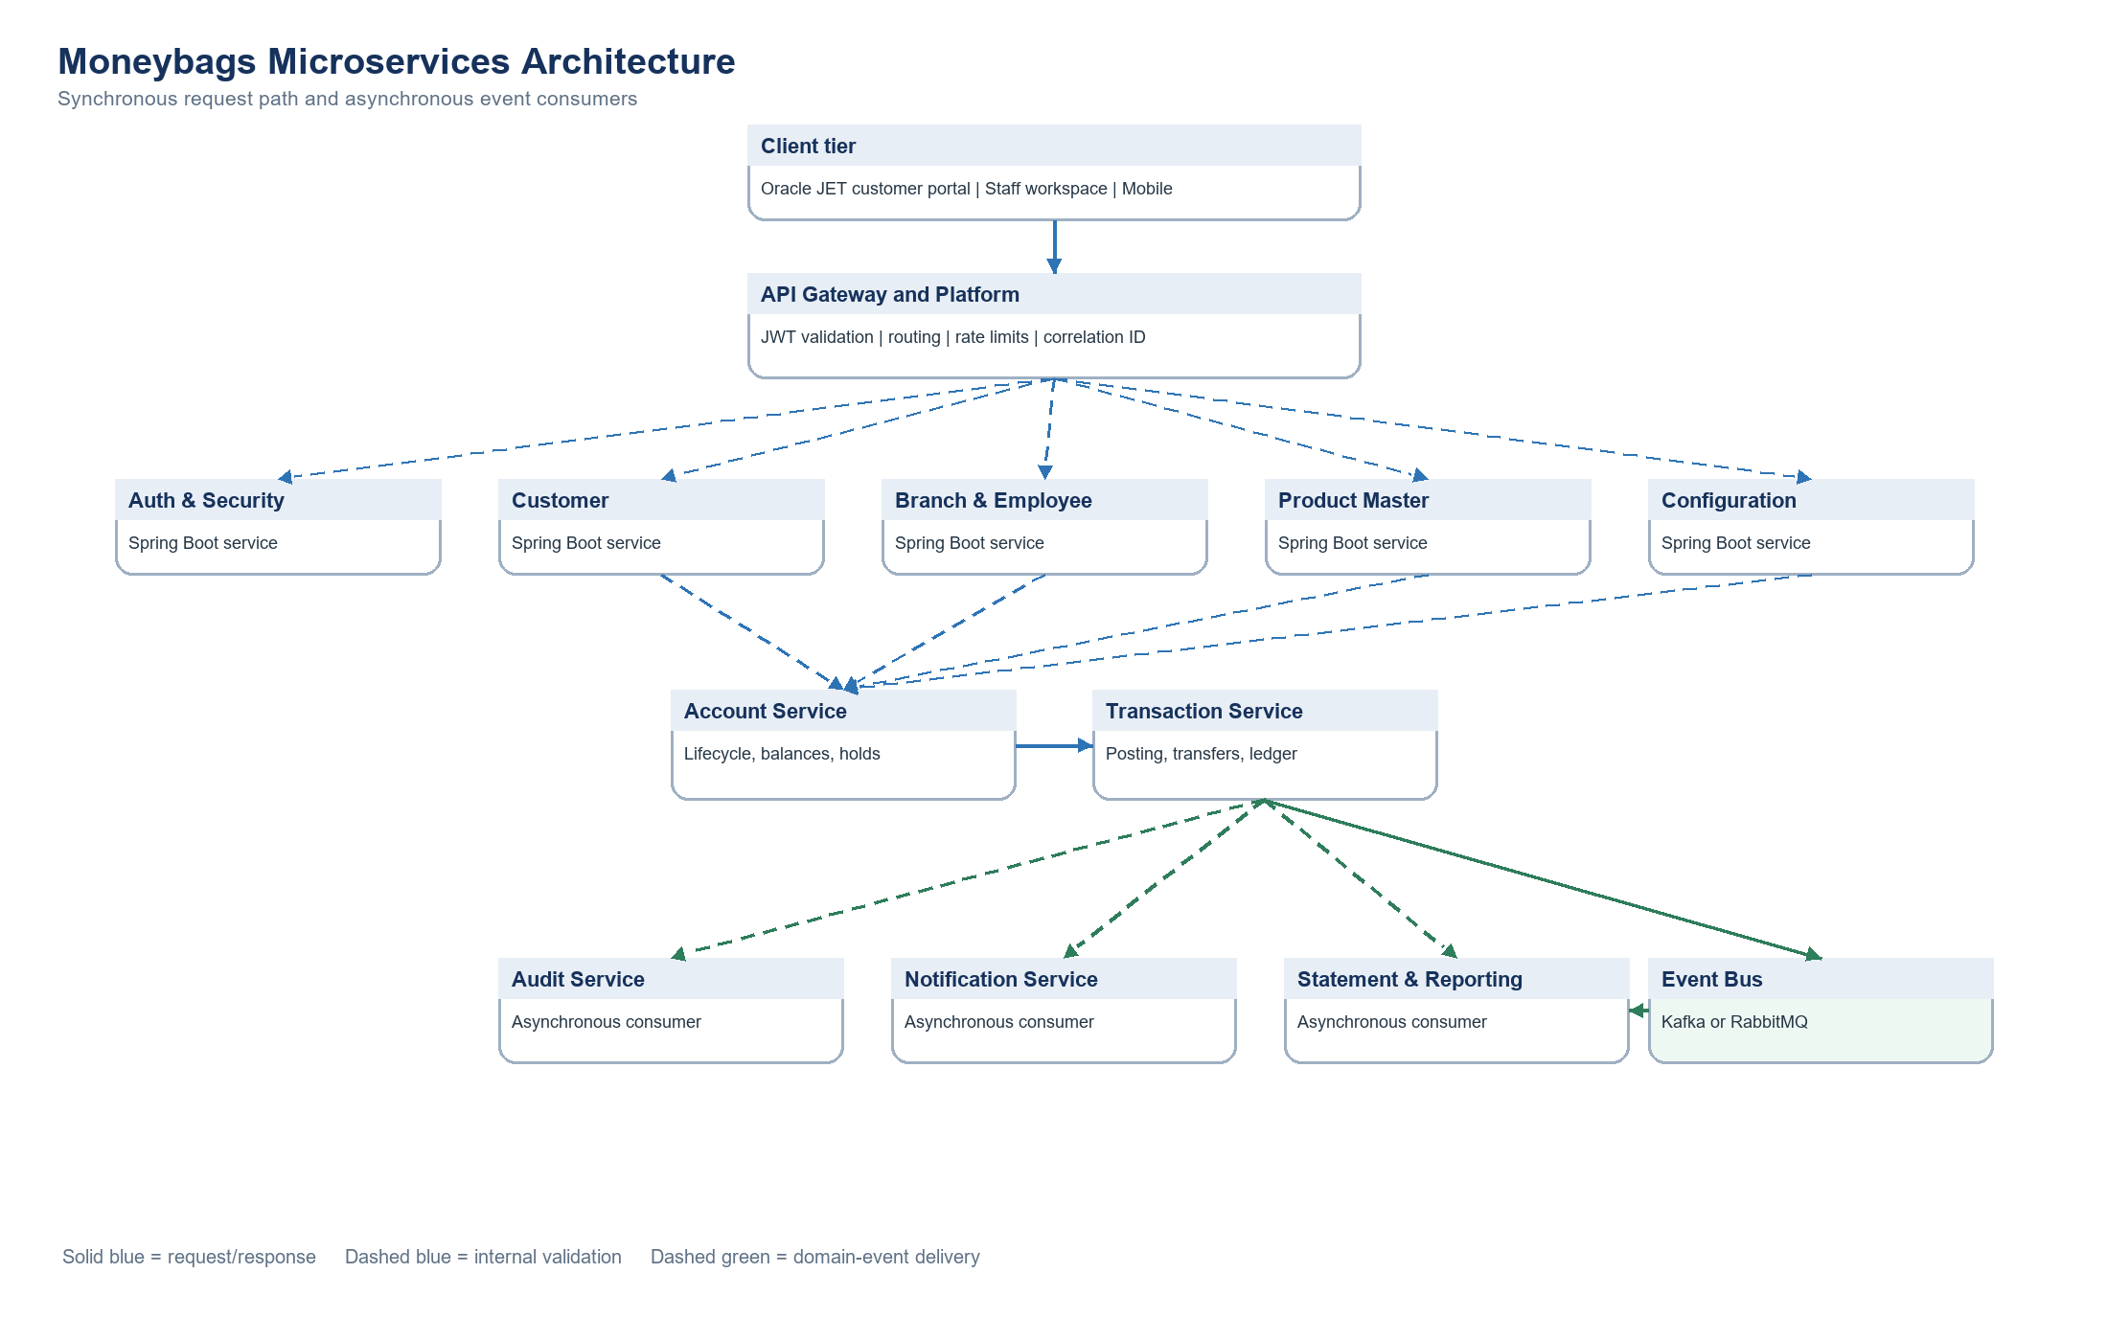
Figure 1. Layered microservices architecture

2.1 Functional service layers
layer | services | purpose
Layer 1 - Access and cross-cutting | API Gateway, Auth & Security, Configuration | Entry security, routing, identity, permissions and shared policies
Layer 2 - Master data | Customer, Branch & Employee, Product Master | Authoritative CIF, organisation and product catalogue
Layer 3 - Account lifecycle | Account Service | Account creation, approval, balances, holds, status and interest
Layer 4 - Financial processing | Transaction Service | Idempotent posting, payments, transfers and double-entry ledger
Layer 5 - Downstream consumers | Audit, Notification, Statement & Reporting | Compliance, alerts, read models and exports

2.2 Communication matrix
source | target | interaction | purpose
API Gateway | All user-facing services | REST | Route requests, validate JWT, rate-limit and propagate correlation ID
Account | Customer | REST | Verify CIF, status and KYC
Account | Product Master | REST/cache | Retrieve product 1-6 rules, rate, minimum balance and tenure
Account | Branch & Employee | REST | Validate branch and approver authority
Transaction | Account | REST/gRPC | Validate status, balance and holds; apply idempotent debit/credit
Transaction | Customer | REST/cache | Validate beneficiary
Transaction | Configuration | REST/cache | Read limits and feature flags
Transaction | Event Bus | Event | Publish completed, failed and reversed outcomes
All services | Audit | Event | Append compliance and mutation records
Event Bus | Notification / Reporting | Event | Send alerts and update reporting read models

Boundary rule: Transaction Service owns transactions and ledger entries. It must never write directly into Account Service tables. Account balance changes occur through an idempotent Account Service command or through a clearly defined co-located posting boundary if the team intentionally combines those components.

3. Detailed Service Responsibilities and Communication

3.1 API Gateway & Platform
Single entry point for Oracle JET and staff channels.

Functions
- Route and version APIs
- Validate JWT signature and coarse authorities
- Apply CORS, rate limits and request-size limits
- Create X-Correlation-ID
- Apply timeouts/circuit breakers
- Aggregate OpenAPI and telemetry

Communication
- Calls every user-facing service over REST
- Uses Auth public key/JWKS without per-request token introspection
- Publishes only operational security events

3.2 Authentication & Security
Identity, credentials, sessions, roles and permissions.

Functions
- Register users and hash passwords with BCrypt
- Login, refresh-token rotation and logout
- Forgot/reset/change password
- OTP challenges and expiry
- Account lock/unlock
- CRUD roles and permissions
- Map roles to permissions
- Session revocation and security audit publishing

Communication
- Notification delivers OTP/security alerts
- Audit consumes LoginFailed, PasswordChanged and PermissionChanged
- Gateway reads token claims and verifies signature

3.3 Customer
Authoritative CIF, KYC, address and beneficiary service.

Functions
- Generate CIF
- Register/search/update customer
- Manage addresses and communication preferences
- Upload KYC references and hashes
- Verify/reject KYC
- Risk classification
- Nominee and beneficiary management
- Document-expiry alerts

Communication
- Account calls eligibility/KYC APIs
- Transaction validates beneficiaries
- Publishes KycVerified and BeneficiaryActivated events

3.4 Branch & Employee
Organisation, branch, employee and approval-authority service.

Functions
- Branch CRUD and IFSC management
- Working hours and holidays
- Employee profiles and branch transfer
- Reporting hierarchy
- Approval limits and maker-checker authority
- Employee search

Communication
- Account validates servicing branch and account approver
- Transaction validates high-value approver
- Auth USER_ID is a logical reference

3.5 Product Master
Authoritative catalogue for SAV-REG, SAV-SENIOR, CUR-BASIC, FD-12M, FD-24M and RD-12M.

Functions
- Product CRUD and versioning
- Expose interest rate, minimum balance and tenure
- Demand-deposit vs term-deposit eligibility
- Interest accrual and payout parameters
- Charges and penalties
- Activate/deactivate catalogue entries
- Public and internal catalogue queries

Communication
- Account reads product during opening and interest jobs
- Reporting uses product code for segmentation
- Publishes ProductRateChanged for cache invalidation

3.6 Account
Account lifecycle, balances, controls, holders and interest.

Functions
- Open and approve accounts
- Generate account number
- Single and joint ownership
- Operating instructions
- Activate/freeze/unfreeze/block/close
- Ledger and available balance inquiry
- Holds, liens and limits
- Nominee mapping
- Daily balance and interest accrual
- Closure settlement

Communication
- Calls Customer, Product and Branch during opening
- Exposes authorise/debit/credit/hold commands to Transaction
- Publishes account lifecycle and InterestPosted events

3.7 Transaction
Idempotent financial execution and double-entry posting.

Functions
- Deposit and withdrawal
- Internal transfer, NEFT, RTGS, IMPS and UPI
- Cheque clearing
- REQUEST_REF idempotency
- Validation pipeline
- Maker-checker routing
- Balanced ledger posting
- Reversal/cancellation
- History and mini statement
- Publish final outcome events

Communication
- Calls Account for controlled balance changes
- Calls Customer for beneficiary validation
- Reads Config limits
- Notification, Audit and Reporting consume events

3.8 Statement & Reporting
Read-heavy statements, certificates and operational reports.

Functions
- Mini/date-range/monthly/yearly statements
- PDF, CSV and Excel export
- Scheduled statements
- Download history
- Daily transaction and branch reports
- Dormant-account reports
- Interest and TDS certificates
- Event-fed read model

Communication
- Consumes Account/Transaction events
- Uses synchronous source APIs only as fallback
- Stores generated-file metadata and authorised download links

3.9 Notification
Asynchronous SMS, email, push and OTP delivery.

Functions
- Consume domain events
- Template rendering
- SMS/email provider adapters
- OTP delivery
- Transaction/account/KYC alerts
- Retry with backoff
- Delivery history and deduplication

Communication
- Consumes events; does not participate in financial commits
- Direct internal API permitted for urgent OTP delivery
- Publishes NotificationFailed for operations

3.10 Audit
Append-only security and business audit trail.

Functions
- Consume mutation events
- Capture old/new values
- Record actor, service, IP and correlation ID
- Search login, account and financial audit
- Export for auditors
- Retention and archival

Communication
- Consumes events from every service
- Must not call source services during normal event handling
- Audit failure never rolls back completed banking transaction

3.11 Configuration
Dynamic limits, policies, calendars and feature flags.

Functions
- Channel and rail limits
- Password and session policy
- OTP expiry
- Holiday calendar
- Maintenance windows
- Maker-checker thresholds
- Feature flags and cache invalidation

Communication
- Auth, Account and Transaction cache configuration
- Publishes ConfigurationChanged
- Audit records every configuration mutation

4. Expanded End-to-End Flows
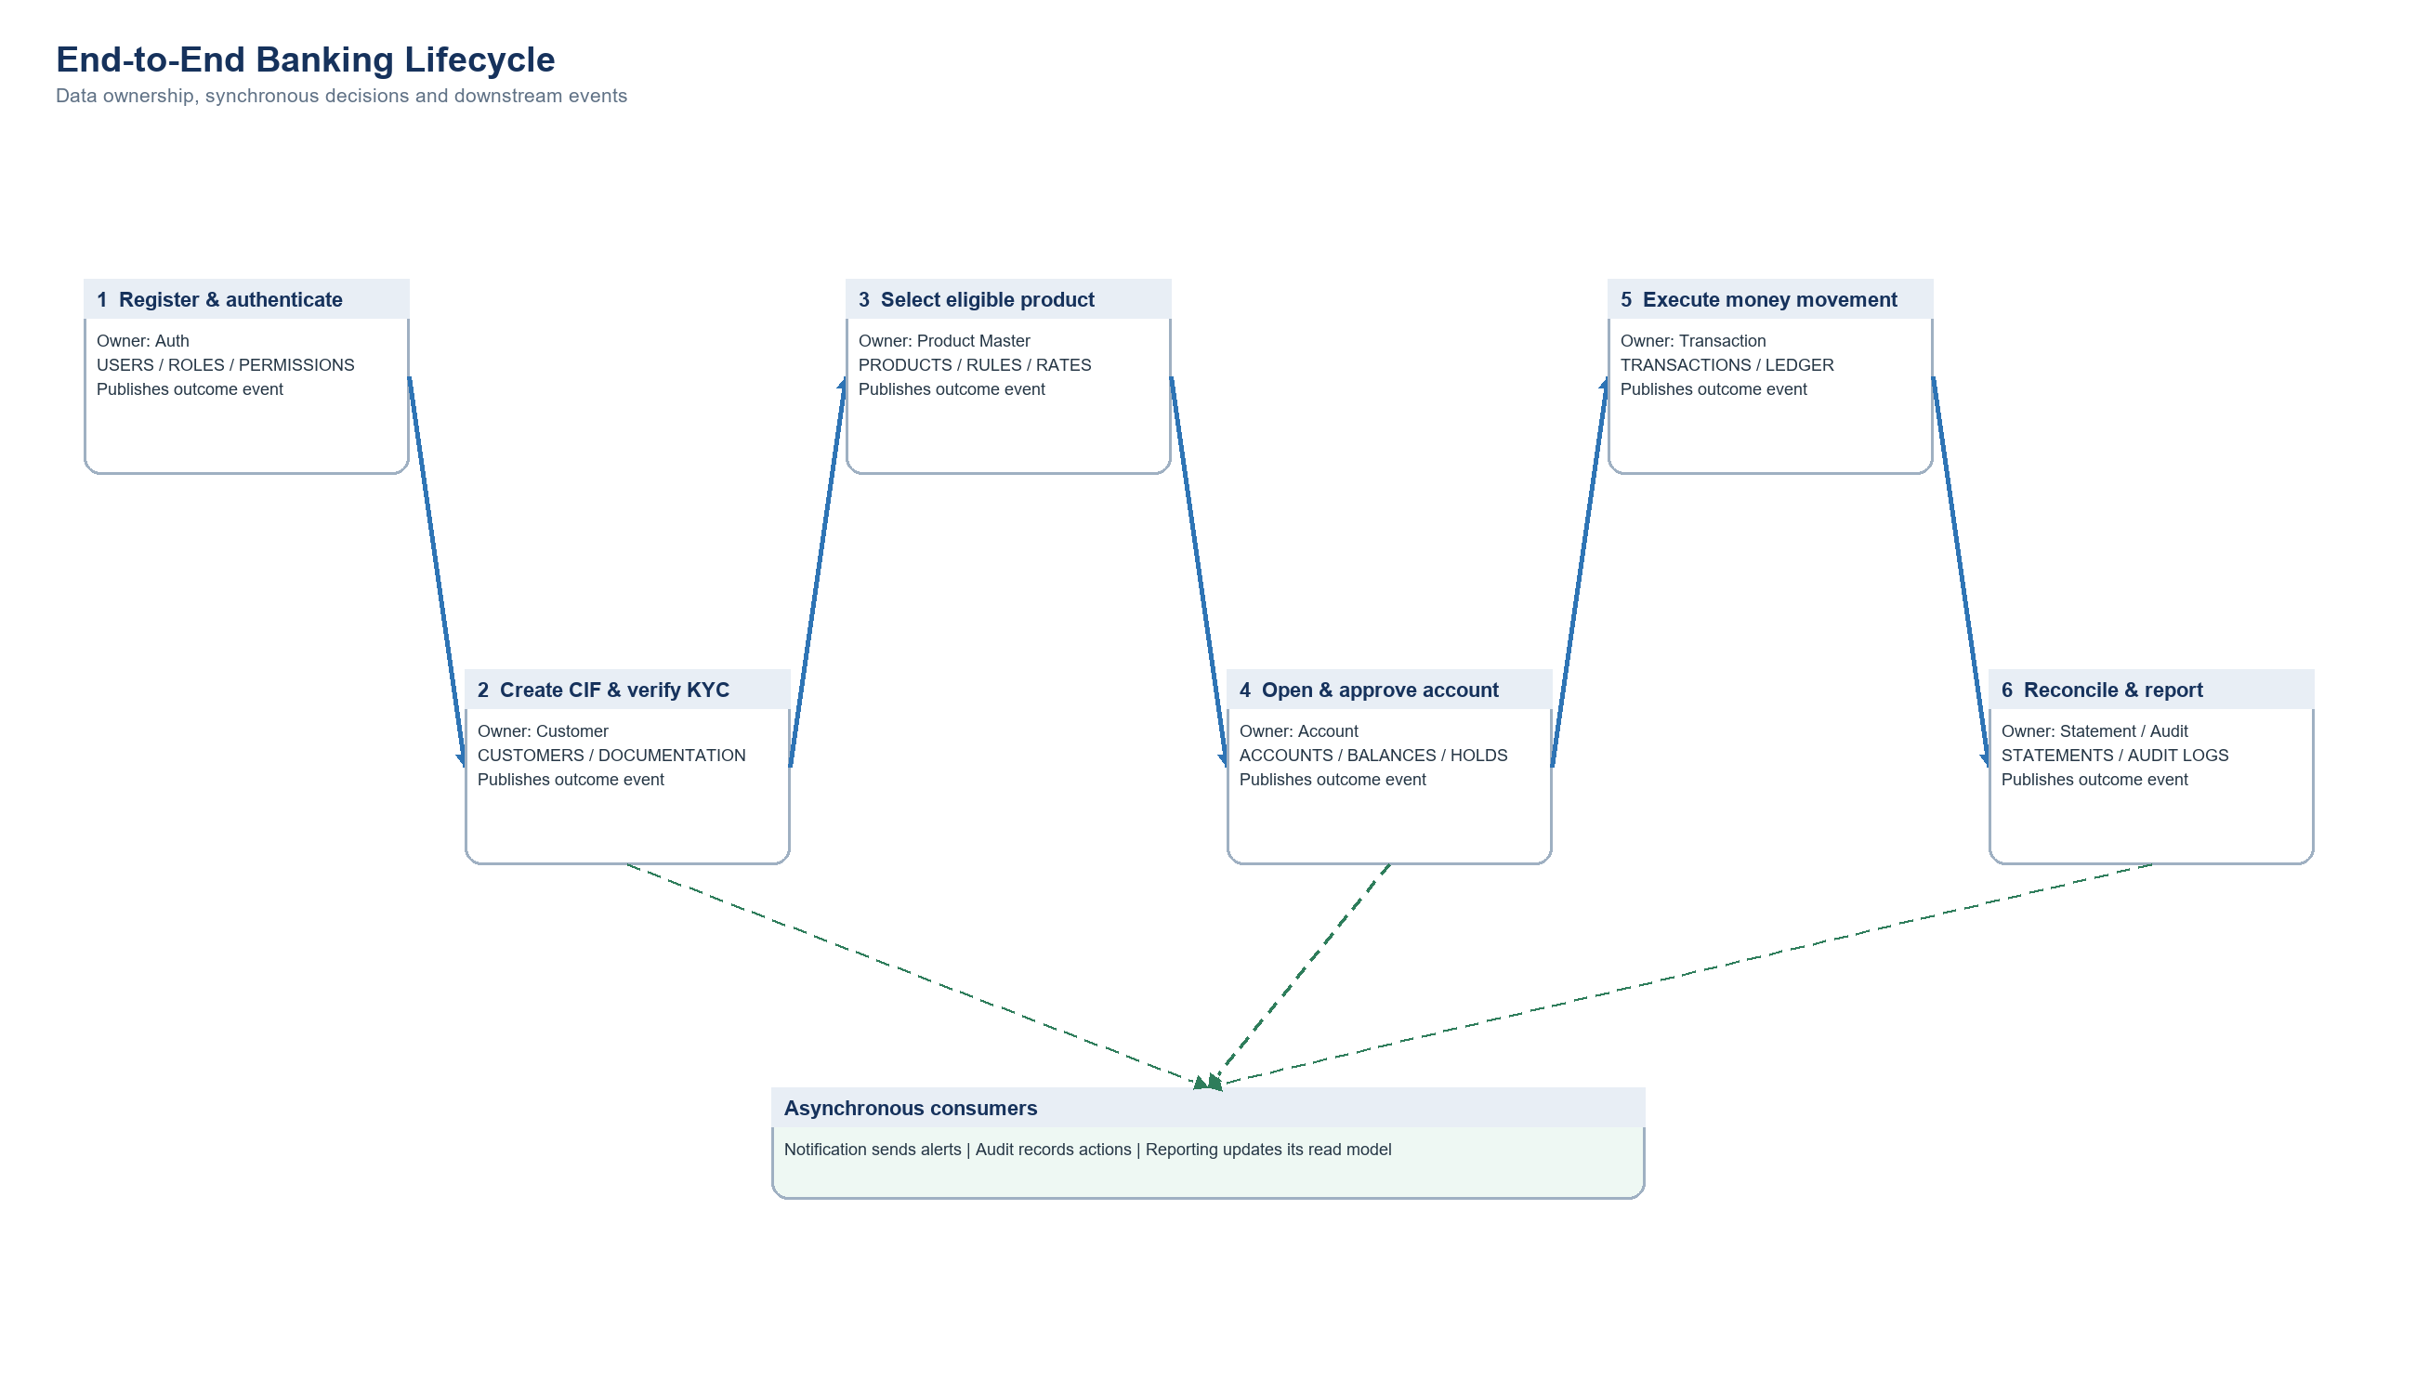
Figure 2. End-to-end banking lifecycle

4.1 User onboarding and KYC verification
step | owner / call | processing | data or outcome
1 | Client -> Gateway | Submit registration; Gateway validates request shape and rate limit | No banking data yet
2 | Auth | Create USERS row with CUSTOMER role and hashed password | UserRegistered outbox event
3 | Customer | Create CIF with KYC_STATUS=PENDING and logical USER_ID | CUSTOMERS insert
4 | Customer | Upload document to secure storage; store hash and path only | CUSTOMER_DOCUMENTATION insert
5 | Branch employee | Review document and customer data | Requires KYC_VERIFY
6 | Customer | Set VERIFIED/REJECTED with verifier and timestamp | KycVerified or KycRejected event
7 | Audit / Notification | Append audit record and notify customer | Asynchronous; retry independently

4.2 Product selection and account opening
step | owner / call | processing | control / data effect
1 | Product | Return active catalogue: SAV-REG through RD-12M | PRODUCT_READ
2 | Client | Select product code and branch; provide holder/nominee instructions | Account application DTO
3 | Account -> Customer | Validate CIF active, KYC verified and age/residency eligibility | Immediate REST decision
4 | Account -> Product | Read rate, min balance and tenure | Product ID/code stored as logical reference
5 | Account -> Branch | Validate branch and employee authority | Branch must be ACTIVE
6 | Account | Create PENDING_APPROVAL account and zero balance row | Idempotent application reference
7 | Transaction | Post required opening deposit where applicable | Normal transaction and ledger records
8 | Manager | Approve application; maker cannot approve own work | ACCOUNT_APPROVE
9 | Account | Transition to OPEN/ACTIVE and publish AccountOpened | Notification, Audit, Reporting consume

4.3 Funds transfer and double-entry posting
A transfer is a distributed workflow. The original request and every Account Service command carry the same REQUEST_REF/correlation ID. The original transaction is never deleted, and retries return the previously committed result.
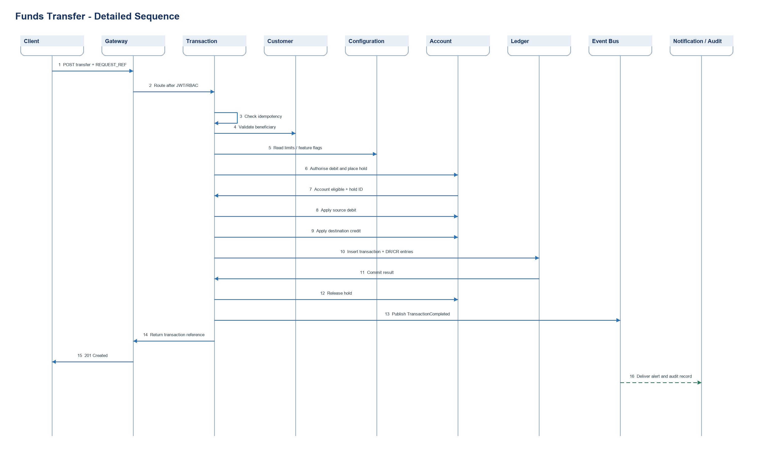
Figure 3. Funds-transfer sequence
failure point | required handling
Duplicate request | Return the original transaction result; do not debit again
Beneficiary/limit validation fails | Reject before placing a hold
Debit succeeds but credit fails | Run Saga compensation: reverse debit or retain recoverable pending state
Ledger commit fails | Do not publish TransactionCompleted; reconcile account command using REQUEST_REF
Event publication fails | Outbox publisher retries without replaying the financial command
Notification fails | Retry notification; financial transaction remains committed

4.4 End-of-day balance and interest posting
- Close the business date and prevent two EOD jobs from processing the same account/date.
- Select eligible OPEN accounts and compute the daily closing balance.
- Resolve the effective product: SAV-REG 3.00%, SAV-SENIOR 3.50%, CUR-BASIC 0.00%, FD-12M 6.80%, FD-24M 7.10% or RD-12M 6.50%.
- For savings, accrue daily interest using eligible balance x annual rate / day-count basis. For FD/RD, use product tenure and deposit schedule rules.
- Store accrual with account, business date, product version and calculation inputs.
- At the payout frequency, create an INTEREST_POSTING credit transaction and balanced ledger entries.
- Update Account balance through an idempotent credit command.
- Publish InterestPosted for statement, audit and notification consumers.
- Reconcile total interest expense against customer credit entries before closing EOD.

4.5 Statement generation
- Account and Transaction events continuously update the reporting read model.
- Customer requests an account, date range and output format through the Gateway.
- Reporting validates STATEMENT_VIEW and confirms account ownership or staff scope.
- Reporting reads opening balance, ordered ledger postings, reversals and closing balance.
- Generated PDF/CSV/Excel is stored using an opaque file key; STATEMENT_REQUESTS records status and checksum.
- A short-lived authorised download link is returned.
- StatementGenerated and any failure event are audited.

4.6 Reversal and reconciliation
- Locate the original successful transaction and verify it is reversible.
- Require TRANSACTION_REVERSE and maker-checker approval above the configured threshold.
- Create a new reversal reference linked to the original; never update the original amounts.
- Apply compensating Account Service commands using a new idempotency key.
- Insert opposite ledger entries whose total balances to zero with the original posting set.
- Publish TransactionReversed and refresh reporting projections.
- Daily reconciliation compares account balances, transaction totals and ledger totals; exceptions enter an operations queue.

5. Privacy, Accounting and Operational Safeguards
- Store Aadhaar and similar identity values in an approved vault/tokenisation model. Application outputs display only masked values.
- Store document hashes and storage references, not unprotected document numbers or binary files in general-purpose tables.
- Every successful financial event must produce balanced debit and credit ledger entries.
- Use optimistic version checks or narrowly scoped row locking to prevent concurrent double-spend. Do not hold database locks across remote network calls.
- Encrypt data in transit and at rest; rotate secrets through a secrets manager.
- Mask account numbers and mobile numbers in logs and notifications.
- Use transactional outbox/inbox tables for reliable event delivery and consumer deduplication.
- Propagate correlation ID, actor ID, branch scope and request ID through APIs and events.
- Reconcile Account balances against Ledger entries daily and alert on differences.

6. Implementation Checklist by Microservice

API Gateway & Platform
- Implement Spring Cloud Gateway routes.
- Implement JWT/RBAC filters.
- Implement Redis rate limiting.
- Implement CORS.
- Implement Correlation ID.
- Implement Resilience4j.
- Implement OpenAPI aggregation.
- Implement Logs, metrics and traces.

Authentication & Security
- Implement Users, roles, permissions and mappings.
- Implement Registration/login/refresh/logout.
- Implement Password and OTP flows.
- Implement Password history.
- Implement Lock/unlock.
- Implement Session revocation.
- Implement Permission CRUD.
- Implement Security events.

Customer
- Implement CIF generation.
- Implement Customer search/update.
- Implement Address CRUD.
- Implement KYC storage reference.
- Implement Verification workflow.
- Implement Nominees/beneficiaries.
- Implement Risk classification.
- Implement KYC events.

Branch & Employee
- Implement Branch CRUD and IFSC.
- Implement Working hours/holidays.
- Implement Employee profiles.
- Implement Transfers and hierarchy.
- Implement Approval limits.
- Implement Authority lookup.
- Implement Search APIs.

Product Master
- Implement Seed products 1-6.
- Implement Product CRUD/versioning.
- Implement Interest/minimum/tenure rules.
- Implement Charges and penalties.
- Implement Lifecycle controls.
- Implement Catalogue API.
- Implement Product change events.

Account
- Implement Opening and account number.
- Implement Approval/rejection.
- Implement Lifecycle state machine.
- Implement Joint holders and instructions.
- Implement Balances and inquiries.
- Implement Holds/liens/limits.
- Implement Nominee mapping.
- Implement Interest and closure jobs.

Transaction
- Implement Idempotency store.
- Implement Validation pipeline.
- Implement Deposit/withdrawal/transfers.
- Implement Double-entry engine.
- Implement Maker-checker.
- Implement Reversal/cancellation.
- Implement History.
- Implement Outcome events.

Statement & Reporting
- Implement Read model.
- Implement Mini/date-range statements.
- Implement PDF/CSV/Excel.
- Implement Schedules.
- Implement Download history.
- Implement Operational reports.
- Implement Interest/TDS certificates.

Notification
- Implement Event consumers.
- Implement Templates.
- Implement SMS/email adapters.
- Implement OTP delivery.
- Implement Retries and DLQ.
- Implement History and deduplication.

Audit
- Implement Append-only schema.
- Implement Event consumers.
- Implement Old/new state.
- Implement Context metadata.
- Implement Search/export.
- Implement Retention/archival.

Configuration
- Implement Typed configuration.
- Implement Channel limits.
- Implement Password/OTP/session policies.
- Implement Calendar/windows.
- Implement Maker-checker thresholds.
- Implement Feature flags.
- Implement Change events.

7. Rendered System Diagram Suite
The following figures replace the Mermaid definitions in the supplied specification. They are implementation views rather than executable diagram source.
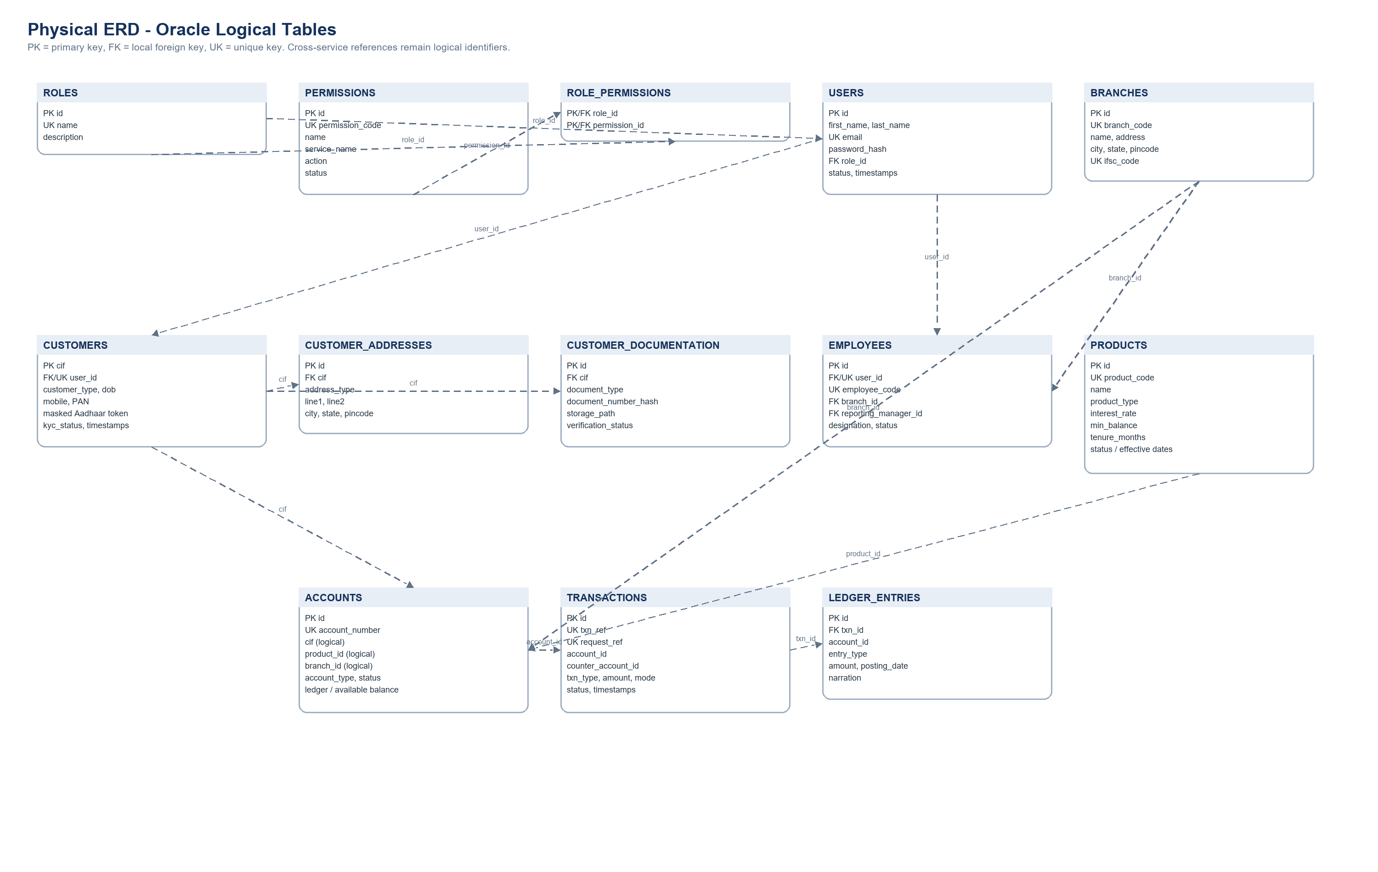
Figure 4. Physical ERD with permissions and revised product model
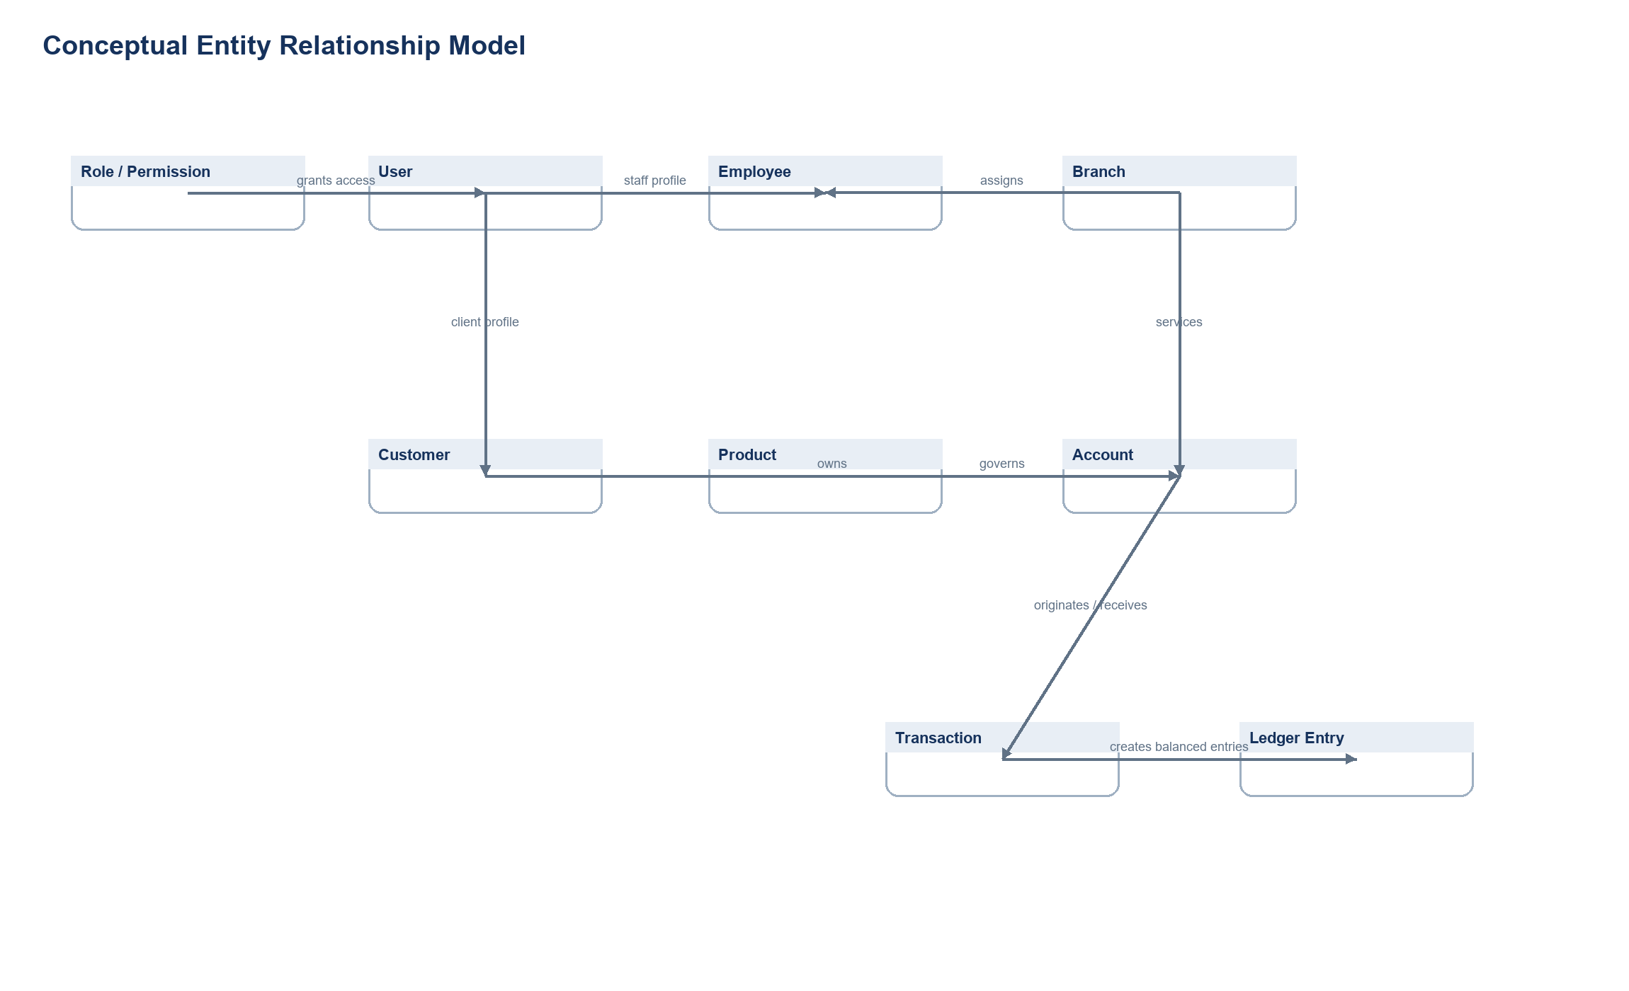
Figure 5. Conceptual entity relationship model

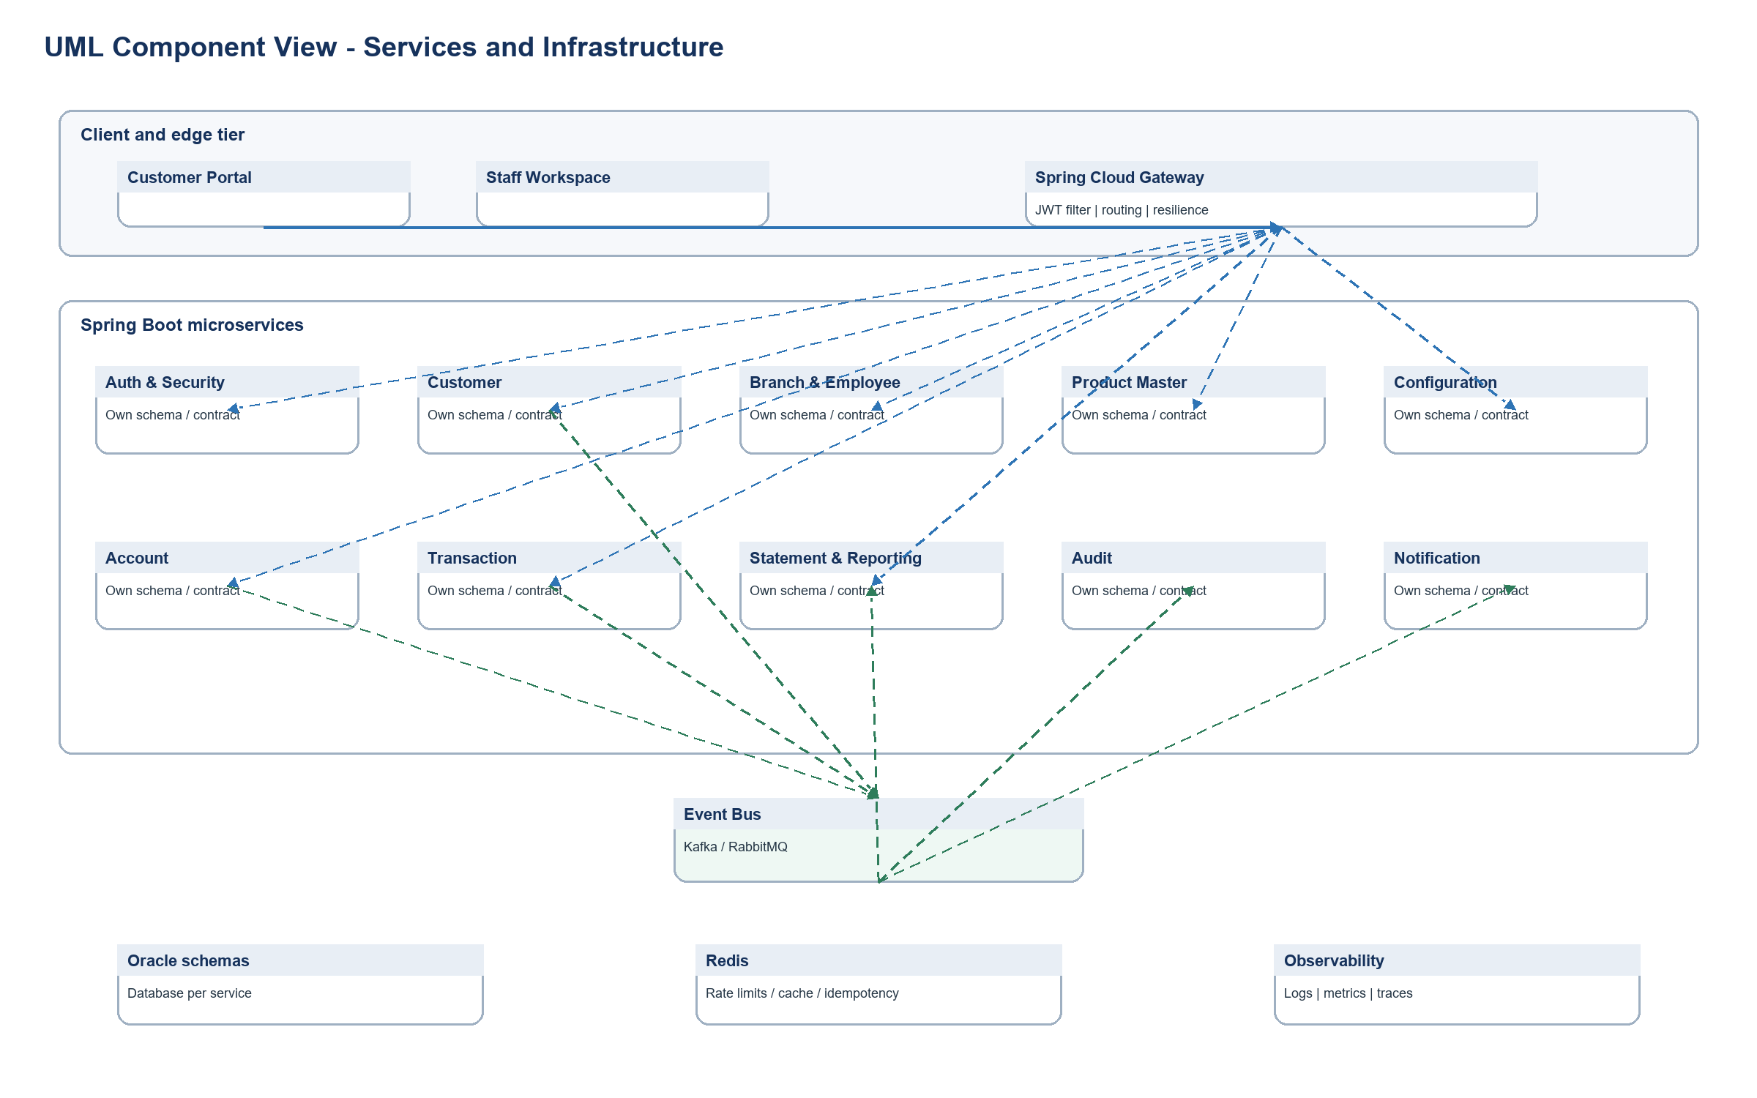
Figure 6. UML component view
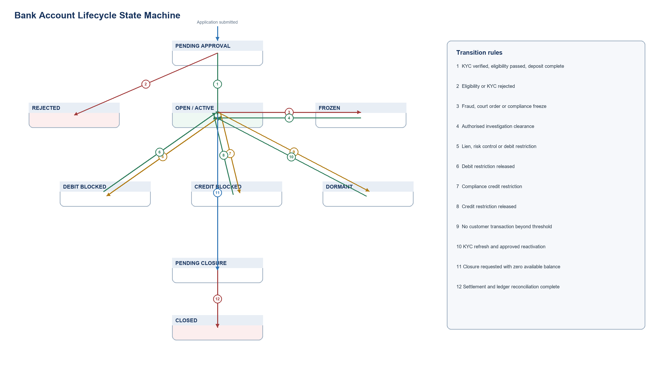
Figure 7. Account lifecycle state machine

